**Lecture 1: personality traits**

*Terminology*

*Personality* the enduring configuration of characteristics and behavior that comprises an individual’s unique adjustment to life, including major traits, interests, drives, values, self-concept, abilities, and emotional patterns.

- personality of the whole

*Personality trait*: a relatively stable, consistent, and enduring internal characteristic that is inferred from a pattern of behaviors, attitudes, feelings, and habits in the individual.

- subpart

🡪 relatively stable; are the personality traits different over time? Do they keep changing? What are the mechanisms

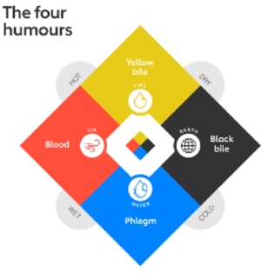🡪 characteristic of what a personality trait is invert from

*History of personality psychology*

4/5 century BC – Hippocrates;

🡪 different bodily fluids; related to how we behave.   
Personality as the ‘four humours’ with two dimension.  
Melancholia – disbalance of the basic humour black bile

Franz Gall (1758-1828) – Phrenology  
A One-on-one link between brain region and function

🡪 bv wiskundeknobbel hebben

Phineas Gage, 1848

Accident with rod, damage to the OFC

🡪 Personality changes tied to brain regions

Psychodynamic view  
• Sigmund Freud 1920’s: The ID, The Ego, Super Ego  
• Carl Jung 1930’s: Personality type theory; Extraversion and introversion

Personality trait theory  
• Francis Galton 1880’s Lexical Hypothesis.   
• Allport 1930’s; 18.000 ‘personality words’

• Raymond Cattel w/ Charles Spearman:, 1940’s factor analyses

• 1960’w Tupes and Christal; 1980’s Digman, Costa and McCrae à Big Five

*Lexical hypothesis:* Traits are words in natural language to describe individual characteristics

(Allport & Oddbert, 1936)

* Hypothesis 1: Important personality characteristics will eventually become a part of that group's language.
* Hypothesis 2: more important personality characteristics are more likely to be encoded into language as a single word.
* Hypothesis 3: Principle Component Analysis of traits can be used to extract important aspects of variation in a population.

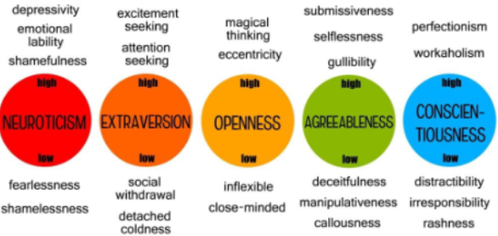*Personality trait research status quo*

* There are many different personality trait models

(NEO-FFI, HEXACO, MMPI).  
Be aware of “jingle/jangle fallacy”.

🡪 all the different models are talking about the

same thing with different terms

* Usually they have about 5-7 factors (“Big 5”).
* Personality traits are hierarchical organized (traits consist of facets, that consist of items)
* Personality traits are related to psychopathology (e.g. Neuroticism -> depression and  
  anxiety)

🡪 traits are a good summary but don’t tell you about a personal narrative.

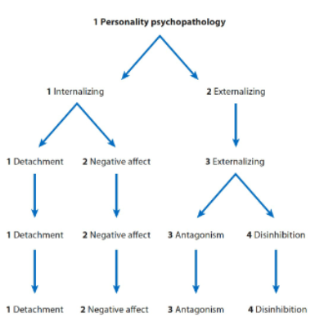🡪 not a good predictor of life events

🡪 not an explanation

*Personality traits and personality disorders (Krueger & Markon, 2014)*

Psychopathology is a broad term that you can split into different branches. The idea is that these 5 traits are a broad way of describing personality disorders.

*Conceptual issues in Personality research*

* Nature and nurture  
  - Is personality more biological or due to the environment?

- Twin research

Two key questions:  
(1) Why are there individual differences in personality? Evolutionary perspective.  
(2) Is personality related to a same/similar set of brain regions across individuals (e.g. Panksepp and emotion systems) or multiple realizable.

1. 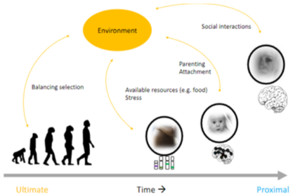Evolutionary perspective: in addition to general adaptations there are mechanism that ‘promote’ individual differences.

• Life history theory. Energy is finite, choices are made on how to use it

=> individual differences  
• Balancing selection  
- Environmental Heterogeneity in Fitness Optima  
- Frequency-Dependent Selection (e.g. repeated Prisoners dilemma, 2% of people will defect, rest cooperate)

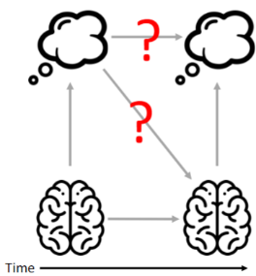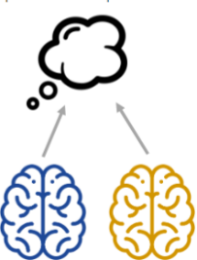(2) Supervenience & Multiple realizability | Identity Theory

Supervenience  
“There cannot be an A-difference without a B-difference”

Multiple realizability:  
Different brain states possibly related to the same mental state.  
Compatible with supervenience.

Identity Theory  
Processes of the mind are identical to states and processes of the brain.

🡪 equifinality: there are multiple ways to reach the same outcome.  
Research shows very weak personality-brain associations which are poorly replicable.  
Brain regions are not specific to personality traits .  
Can brain regions or networks predict Personality (disorders)? .. Only a little bit, ~ 55% accuracy

* Person-situation debate

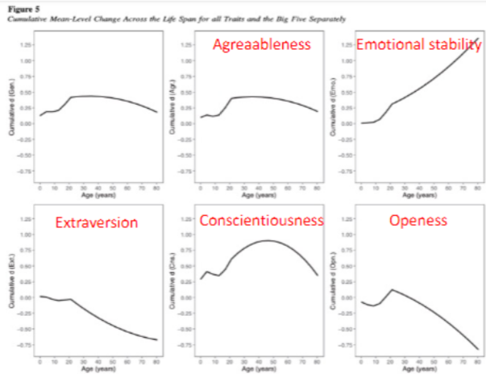Conclusion: there is both stability and variability in personality  
Time scale is key: Moment-to-moment: behavior can be quite different. week-to-week it is quite stable..

* Stability of personality traits

Rank-order stability

🡪 a lot of changes in the age range from 10 - 25, but later it starts to stabilize.

Cumulative mean-level change

*Personality traits conclusion*

* Personality traits status quo: OCEAN model (and many others!), hierarchical organized,  
  somewhat useful, but conceptual issues
* Personality traits are closely related to personality disorders, but role in DSM in still  
  limited and debated.
* Personality conceptual issues:

- Nature and nurture. Both, it is a complex interaction.  
- Person (on longer time scale) and situation (shorter time scale).  
- Stability (mostly >25y) and change (especially for emotional stability).

**Literature:**

Fleeson, W. (2004). [Moving Personality Beyond the Person-Situation DebateLinks to an external site.](https://psycnet.apa.org/record/2004-12676-010). *Current Directions in Psychological Science*, 13(2), 83–87. Retrieved from https://doi.org/10.1111/j.0963-7214.2004.00280.x

Krueger, R. F. & Markon, K. E. [The Role of the DSM-5 Personality Trait Model in Moving Toward a Quantitative and Empirically Based Approach to Classifying Personality and Psychopathology](https://pubmed.ncbi.nlm.nih.gov/24329179/" \t "_blank)*Annual review of clinical psychology* **10**, 477–501 (2014).

🡪**pages 483 -496 are exam material**, where you can **mainly focus on the second section** ("some Key issues..", p483-485), tables 1 and 2, and figure 1.

**The Role of the DSM-5 Personality Trait Model in Moving Toward a Quantitative and Empirically Based Approach to Classifying Personality and Psychopathology - Krueger & Markon (2014)**

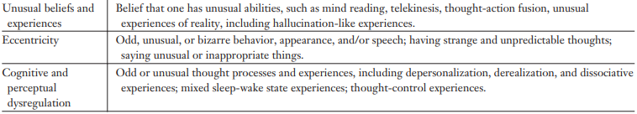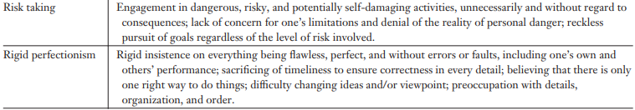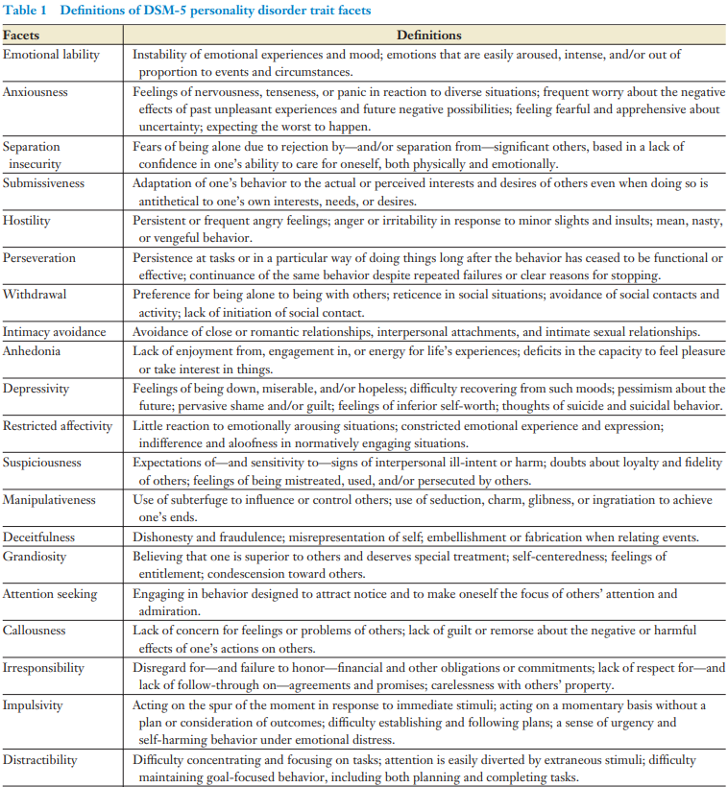

*Interstitiality*: the tendency of some personality constructs to be located in between broader domains of personality variation. For example, a dispositional tendency to be depressed tends to reflect the personality domains of both high negative affect and low positive affect/ introversion (or detachment, using DSM-5 terms for the five major personality domains)

*Range*: the extent to which a specific measure of a personality dimension covers the dimension across its entire theoretical distribution

*Polarity*: the extent to which a specific measure of a personality dimension reflects one or both ends of a personality trait distribution that is theorized to have both a high end and a low end that are conceptual opposites (e.g., introversion versus extraversion)

*Source*: the specific source of personality data, e.g., the self, a knowledgeable informant, a clinician, or a teacher

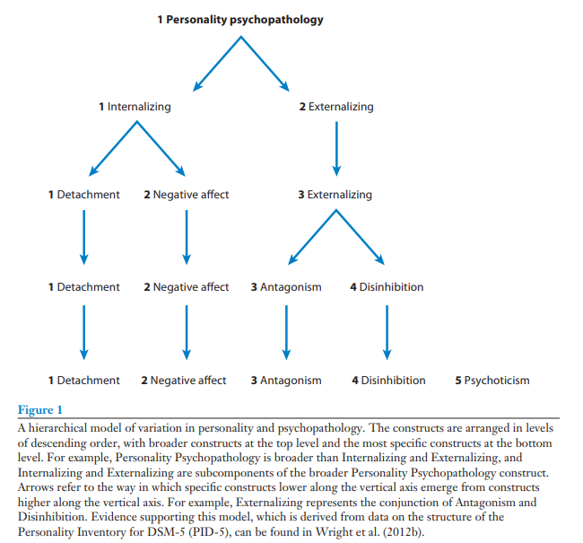 **Lecture 3 – Actor – Agent – Author**

Applied personality assessment – is about the individual 🡪 most interesting.

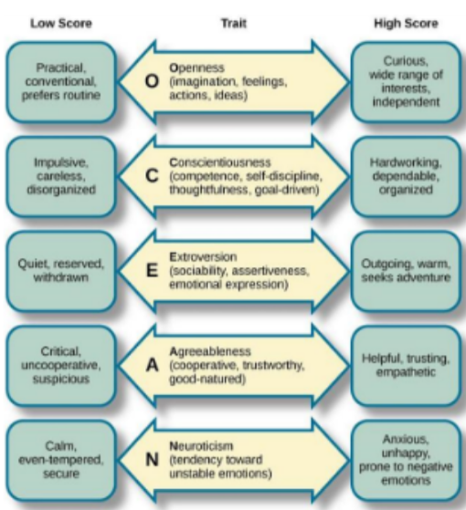*Three layers undergird personality:*

1. Actor 🡪 dispositional traits

Broad dispositional traits, like:

- What kind of actor are you? 🡪

- Styles

- Social Reputations

Seven Up 🡪 follow up interviewing, every seven year a new interview about your life

🡪 story of Bruce: school teacher

1. Agent 🡪 characteristic adaptations

Strivings! A new layer, behavior stems from /is in line with internal(-ized) motivation,

values; time and role specific

🡪 Beyond broad behavioral signatures, social “reputations”

Agenda: Personal Goals, Values, Projects

🡪 Starts around beginning of primary school

No population taxonomy like FFM

🡪 Few instruments in (Clinical) Personality Assessment

For each trait position, there are many alternative adaptations possible ...

🡪 That vary enormously in in societal cost, suffering and personal growth/ stagnation

1. Author 🡪 Narrative IDENTITY

“But we are not objective. We need a narrative to explain how we came to be and

where we might be going. Therefore, we construct life stories – narrative identities – that

provide our life with a temporal sense of continuity. [...] Narrative Identity is a personal

myth.” (McAdams)

🡪 Internalized, evolving personal constructions

🡪 NOT like an objective picture!

🡪 Life Story Interview as a tool to develop your NI

🡪 How we are Unique

Rewriting of NI can then bring about fundamental and pervasive  
behavioral changes (different choices; Timothy Wilson; Therapeutic  
Assessment, Stephen Finn)

But revising centrally held ideas about the Self should be done  
with care: Risk of desintegration anxiety (Kohut)  
Therapeutic Assessment aims to do just that (next lecture)

--------------------------------------------------------------------------------------------------------------------------------------

**Literature:**

* [**narrative week 1 agency and communion-2.pdf**](https://canvas.uva.nl/courses/35272/files/7507557?wrap=1)
* [Dan McAdams (2013). The Psychological Self as Actor, Agent, and Author.](https://lib.uva.nl/permalink/31UKB_UAM1_INST/1hfh82p/cdi_proquest_miscellaneous_1697213028)
* [James Baldwin (1963). The fire next time. pg 23-63.](https://canvas.uva.nl/courses/35272/files/7507606?wrap=1)

---------------------------------------------------------------------------------------------------------------

**McAdams: “The Psychological Self as Actor, Agent, and Author”**

The psychological self is a reflexive arrangement of the subjective I and the construct Me, which evolves and expands over the course of life. Research suggests that semantic (trait-based) and episodic (event-based) knowledge about the self are functionally independent. Rating oneself on traits does not typically activate recall of specific events that indicate the trait (e.g., rating oneself as extravert does not require recall of specific moments where one showed extraverted behaviour). Rather, information from concrete personal experiences is summarised into general semantic categories (trait labels) that one can retrieve.

*Integrative theory of self*

The actor-agent-author framework is an integrative theory of the self that asserts that humans (the I) understand themselves (the Me) from three different standpoints (actor, agent, author) which emerge at different points in their developmental trajectories. Importantly, these layers are not autonomous things or distinct roles that a person might play. They all exist at any given time and place. The self begins life as a social actor, struggling to regulate itself to perform effectively in the social stages of human life. As the person moves into middle childhood, the motivated agent emerges, which broadens focus to the future in the form of goal pursuit. In late adolescence and adulthood, the autobiographical author joins the actor and agent, creating a story about the Me in order to integrate the past, present, and future.

Over the course of life, people reflexively observe their own performances as social actors and monitor the reactions of others: these reactions determine one’s social reputation. Behaviours that are reinforced will be repeated over time, while those that are punished or ignored may decrease or even extinguish. People, including infants, act in purposeful and goal-directed ways, expressing agency. However, the self as a motivated agent only develops when we consciously set goals and plans for our daily lives and organise our behaviour and self-understanding to be consistent with them (see mentalising later on). Children will internalise a theory of mind and gradually integrate their goals with roles of the social actor. People create meaning and purpose in their lives by constructing self-defining stories. The I becomes the author of the story of the Me, aiming to integrate the past, present, and future (narrative identity). The development of narrative identity begins with autobiographical memory but also requires autobiographical reasoning. Autobiographical reasoning is a wide set of interpretive operations through which people draw on autobiographical memories to make inferences about who they are and what their lives mean. Over the lifespan, narrative identity continues to develop, becoming more nuanced and integrative as one grows older.

Each of the layers of the self has central psychosocial problems or challenges for selfhood. These

problems overlap and interact in many ways and can be understood from the three different perspectives:

* Self-regulation (actor): the extent to which the self (the I) has reflexive control over its (the Me’s) feelings, thoughts, impulses, and behaviours in social settings. It is the way the self keeps itself in check to minimise social punishment and maximise social reward.
* Self-esteem (agent): the extent to which the self (the I) feels good about itself (the Me). It

involves the evaluative attributions that the I makes regarding the Me’s worth. The extent to

which one is able to achieve goals appears to be a large determinant of self-esteem.

* Self-continuity/identity (author): the extent to which the I apprehends the Me to be continuous in space and time. Generally, the I may construct a different Me for many different situations, while it aims to construct continuity over time in two forms:

🡪 Phenomenological continuity: a basic, moment-by-moment feeling that the I continues to exist as the same locus of feeling, thought, and consciousness (you expect to wake up as the same person as when you went to bed).

🡪 Narrative continuity: a constructed sense of self as a character in one’s life story. In this form, continuity is demonstrated by a narrative of how the self has changed and

how it remained the same over time. In narrative discontinuity, one might not know

who they really are or want to be.

Culture relates to selfhood in different ways for the different layers:

* Behaviour expression (actor): culture provides norms and constraints for the behavioural expression of an actor’s traits and roles. Social roles entail different behaviours, duties, and customs in different societies.
* Articulation of goals (agent): culture provides timetables, scripts, and strong priorities for the

agent’s articulation of goals and values. Different cultures emphasise different types of goals.

* Psycho-literary menu (author): culture provides the psycho-literary menu off of which the

author chooses the images, metaphors, and narratives that can be used to make narrative

identity. Narrative identities are constructed to make sense in one’s own culture, while it

might not make sense in another. Further, there are differences in autobiographical memories

between cultures.